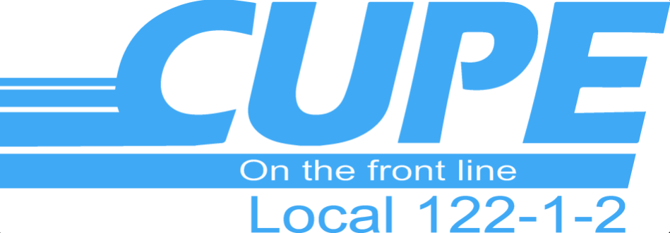

COLLECTIVE BARGAINING 2019
Your Bargaining Committee has designed surveys to define your Collective Bargaining Priorities. Each and every returned survey is important. Your input is critical to the Bargaining Process. Please see your Bargaining Committee member for a copy of this survey. Deadline for completed surveys is September 30, 2019.
Your Bargaining Committee members are:
City Hall – April Adams & Crystal McLeod
Public Works – Mike Pigeau & Brandon Joyes
Parks / Parking – Jamie Carriere
Treatment Plants & Hazardous Waste – Peter Fenton
Arenas – Brent Lavigne
Transit – Paul Boyer
Landfill – April Adams
If you have any questions, concerns, or would like to bring something up, please see your Bargaining Committee member or any member of the Executive, and we will forward the information to the Bargaining Committee on your behalf.
In Solidarity,

Jason Bennett – CUPE 122 Recording Secretary

